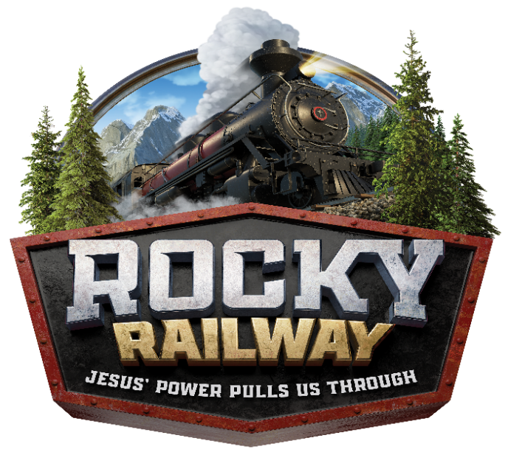
COME JOIN US!
VOLUNTEER SIGN UP FORM:

At ROCKY RAILWAY VBS, you have the opportunity to send kids off with a passion for sharing Jesus’ love in powerful and practical ways! With Jesus’ power we can transform tomorrow’s faith community into an environment of belonging, sharing, caring, and community. Today, help kids discover how Jesus’ power can help them be faithful friends who truly care for each other.

Mark these dates on your calendar:
MONDAY, JUNE 8th, 2020 – FRIDAY, JUNE 12th, 2020

The fun starts at 9:00 a.m. and will end at 12:00 p.m. As a volunteer you need to arrive by 8:30 a.m. and would be done by 12:30 p.m. each day.

Name:_________________________________________ T-Shirt Size:______________

Home Phone: _____________________ Mobile Phone: ________________________ Email: ____________________

Address:_________________________________ City:____________ Zip:_________

(Those that volunteer for the week will be given a t-shirt to wear.)

I am interested in volunteering in the following areas (please rank your top 4 choices-1 being first choice. Volunteers will be assigned to areas in the order in which they are received in the office.)

________ Crew Leader ________ Preschool age Crew Leader

________ Outdoor Games ________ Imagination Station _______KidVid Cinema

________ Bible Stories ________ Snacks ________ Opening Session

I am able to help:

________ All Week ________ Monday ________ Tuesday

________ Wednesday ________ Thursday ________ Friday

**Registrations are due in the Faith Formation Office. **
Call (320) 743-2481 or e-mail stmarcussff@frontiernet.net if you have any questions.

