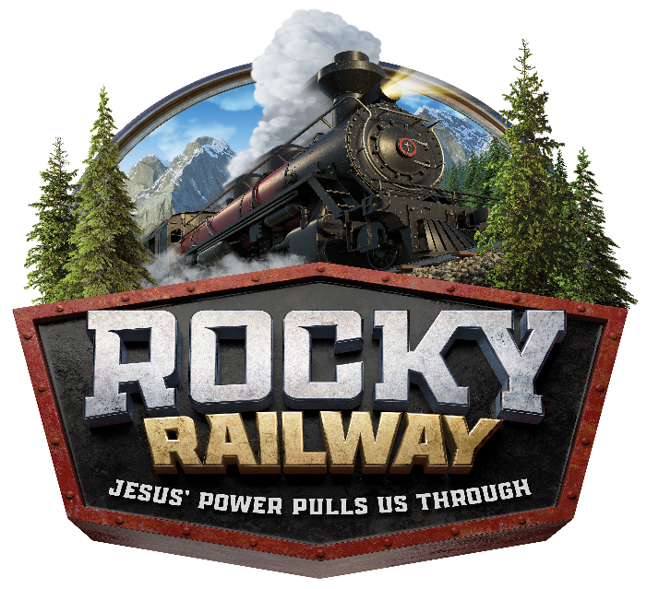
Dear Parents:

At ROCKY RAILWAY VBS, kids discover that Jesus’ power helps us do hard things, Jesus’ power gives us hope, Jesus gives power to the faint and strengthens the powerless, Jesus’ power lets us live forever! Jesus’ power also helps us be good friends and more!!!!

At ROCKY RAILWAY! VBS, kids begin or deepen their faith by discovering that life can get ROCKY and JESUS’ POWER PULLS US THROUGH! ROCKY RAILWAY VBS is filled with incredible Bible-learning experiences kids see, hear, touch, and even taste! Sciency-Fun Gizmos, team-building games, cool bible songs, and tasty treats are just a few of the standout activities that help faith flow into real life. (Since everything is hands-on, kids might get a little messy. Be sure to send them in play clothes and safe shoes.) Plus, we’ll help kids discover how to see evidence of God in everyday life—something we call God Sightings. Get ready to hear that phrase a lot!

So, mark these dates on your calendar:

MONDAY, JUNE 8th, 2020 – FRIDAY, JUNE 12th, 2020
The fun starts at 9:00 a.m. and will end at 12:00 p.m.
VBS is open to kids ages Pre-K through 5th Grade

Call (320) 743-3346 or e-mail stmarcussff@frontiernet.net if you have any questions.

Please return the attached registration form, no later than Friday, May 8th, 2020 (if it is after this date, we cannot guarantee your child will receive a t-shirt). You do not need to be a member of St. Marcus to participate. This will ensure we order enough supplies and t-shirts for the kids. Registration fee is $40.00 for the week, which includes a t-shirt, snacks every day, a science kit to take home each day and lots of other goodies for your child.
If you, as an adult, join our decorating committee and help make decorations AND help decorate the building for VBS (all done before VBS, mostly during the school year and then typically a couple Wednesday evenings in April/May and final decorating the week before VBS in June) or if you sign up to help the week of VBS, your child’s fee for VBS will be waived. Volunteers the week of VBS are needed to lead stations and help with snacks. If the registration fee is an issue, please let us know. No child will be turned away due to a hardship.

Sincerely,
Your ROCKY RAILWAY! VBS Director

